

CENTER OF DIPLOMA STUDIES

DAT 32403

WEB PROGRAMMING HATTA & HALIM

LABORATORY 1: HTML, CSS AND JAVASCRIPT

|  |  |
| --- | --- |
| **NAME** | **QAIREL QAYYUM BIN MUHAMAD RIDHUAN** |
| **MATRIC NUMBER** | **AA212363** |
| **SECTION** | **6** |
| **LECTURER NAME** | **MISS NADIA** |
| **SESSION** | **SEMESTER 1 2022/2023** |

***Question 1: Create an HTML Page as Figure 1.2 below to view your profile card based on given criterion in Table 1.0***

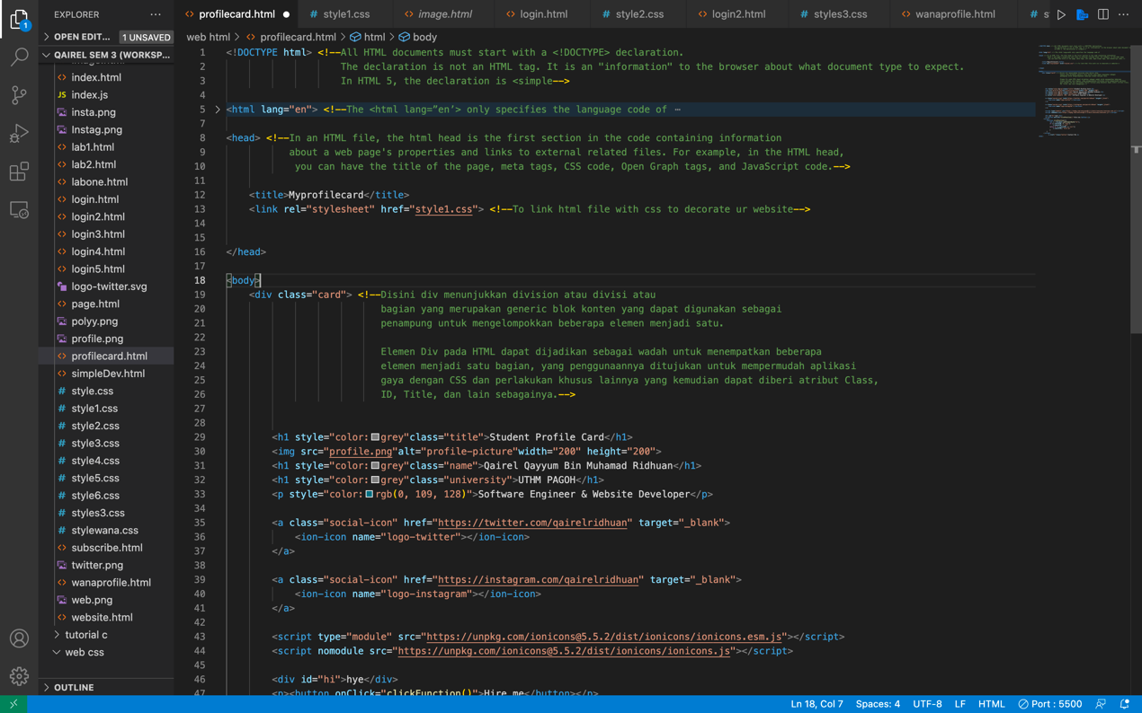

***Question 2: Using JavaScript add one more button namely “Hire Me” with functional of three times prompt. 1st (“Hye”), 2 nd (“Sir”) and 3rd (“Hire Me”).***

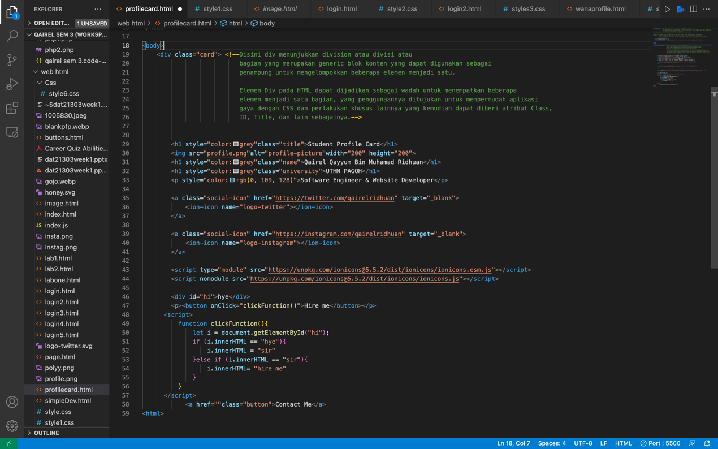

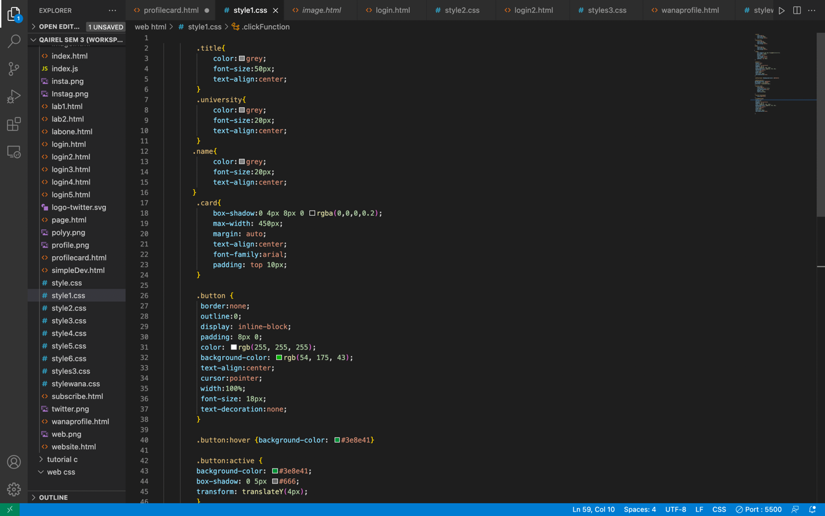

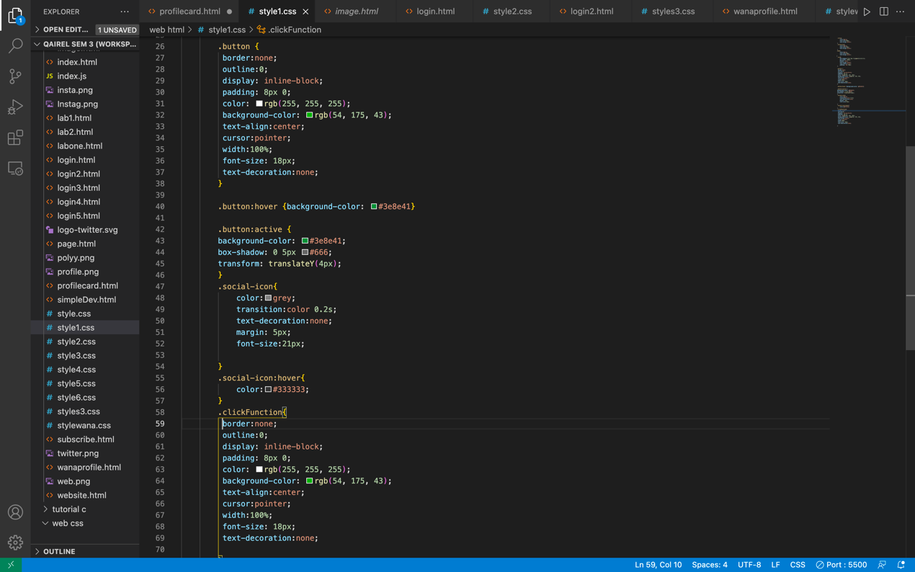

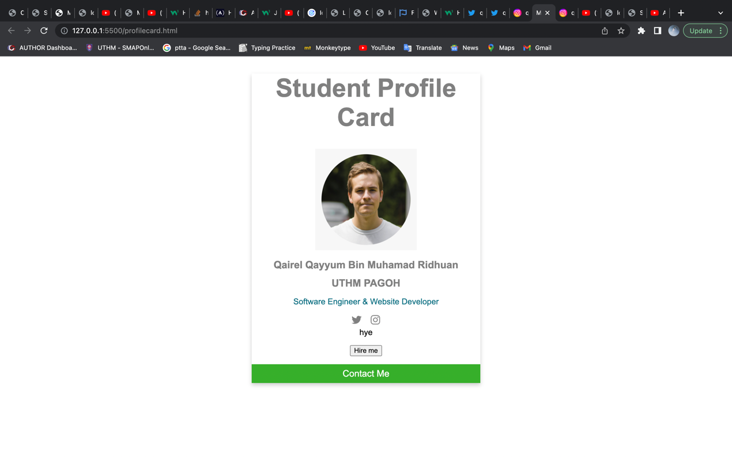

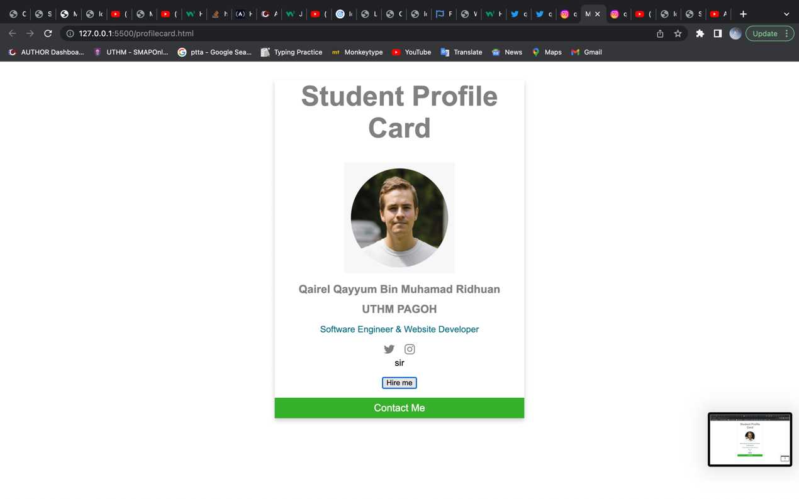

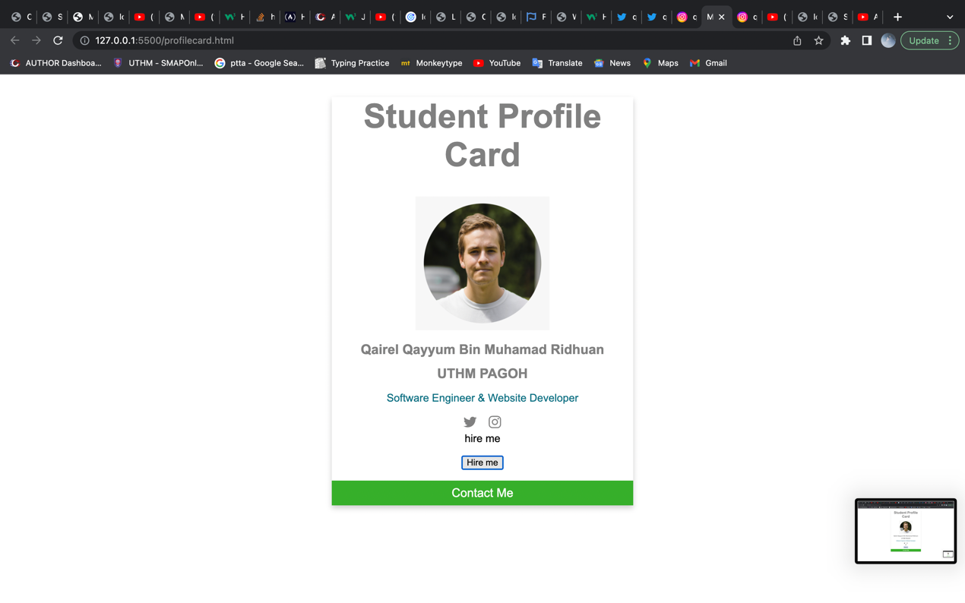

***Question 3: Based on Figure 1.3 below is about a form of HTML. You are required to attach the form with JavaScript form Validation. You are freely to use either alert or text mechanism to show the validation messages.***

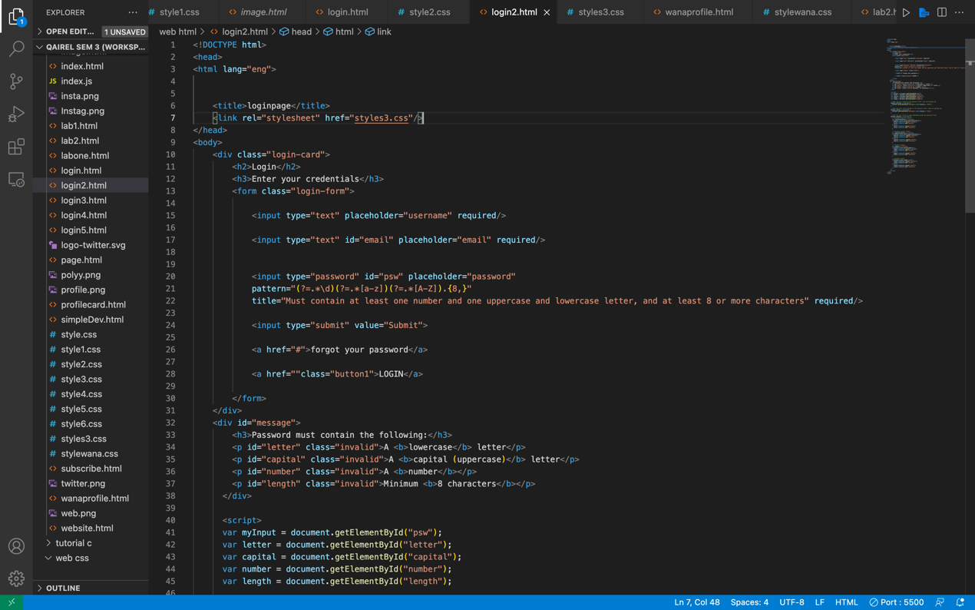

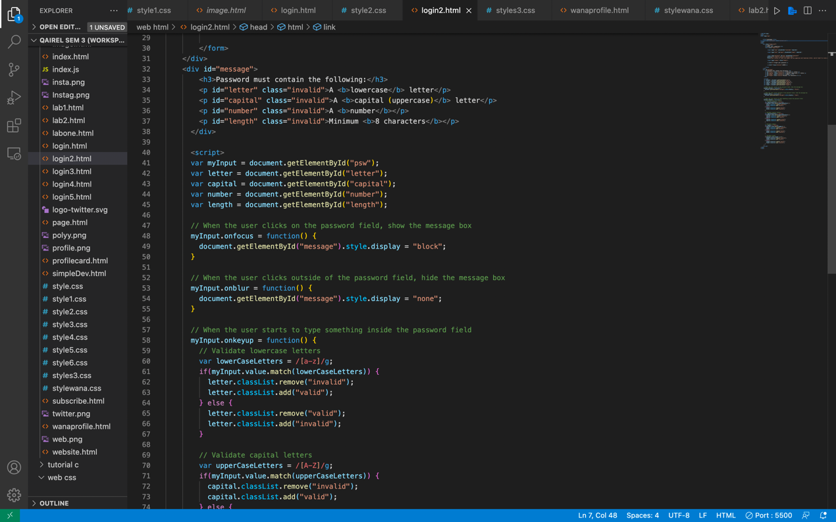

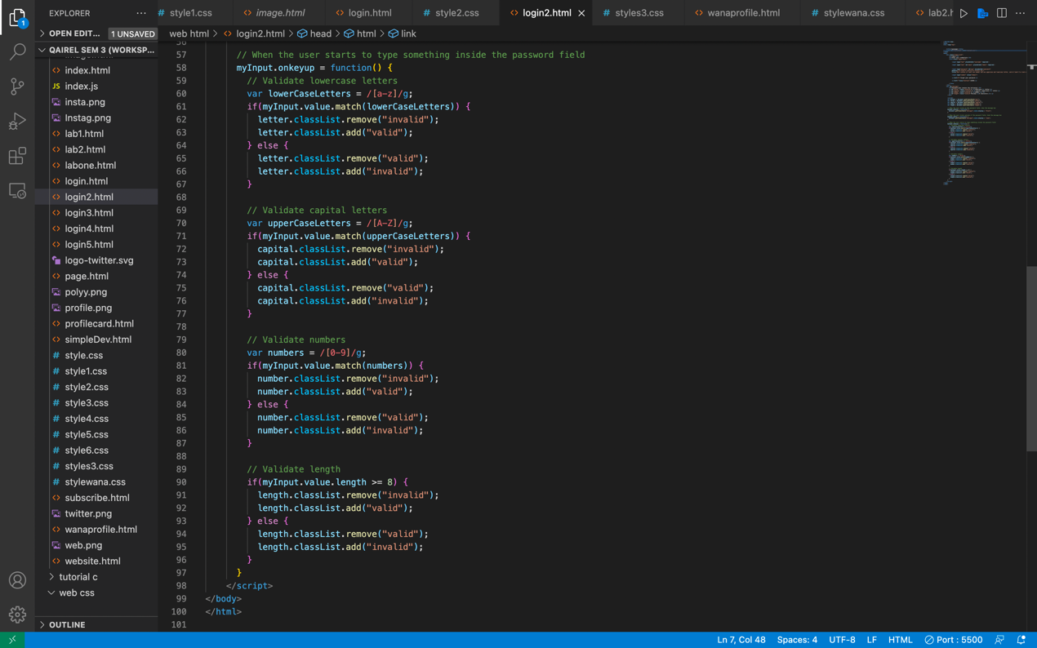

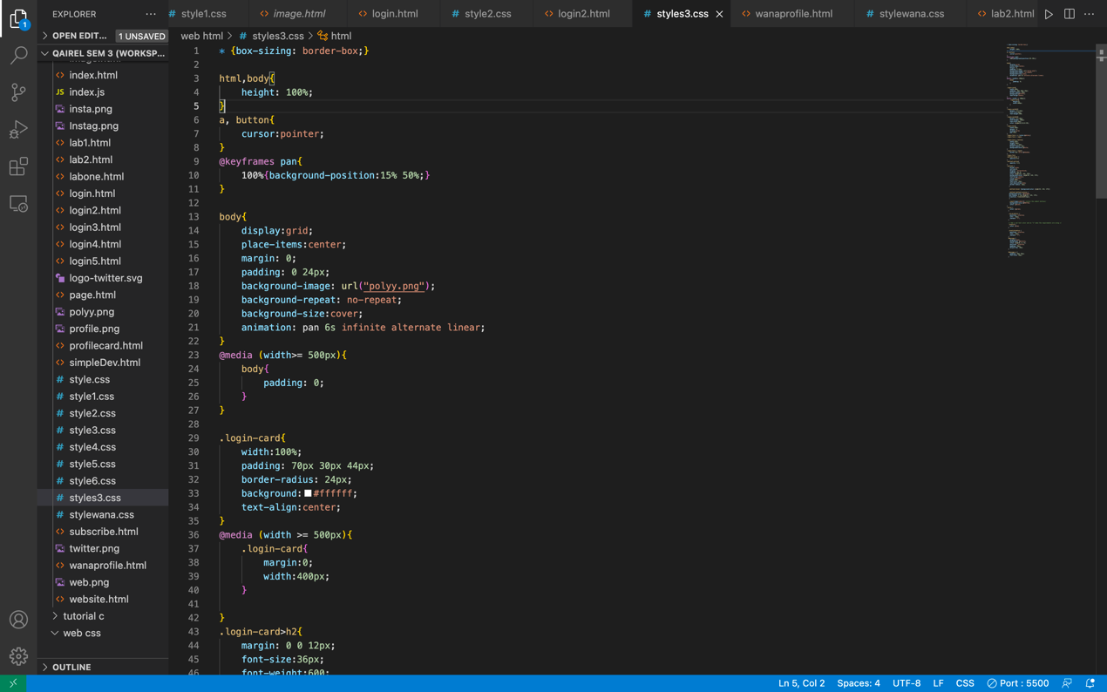

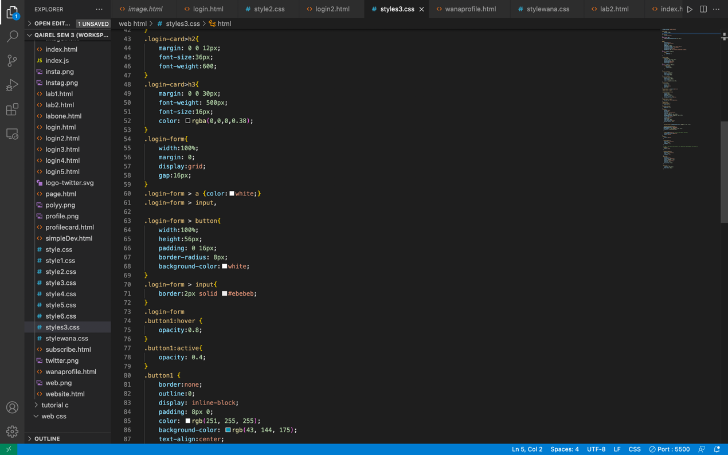

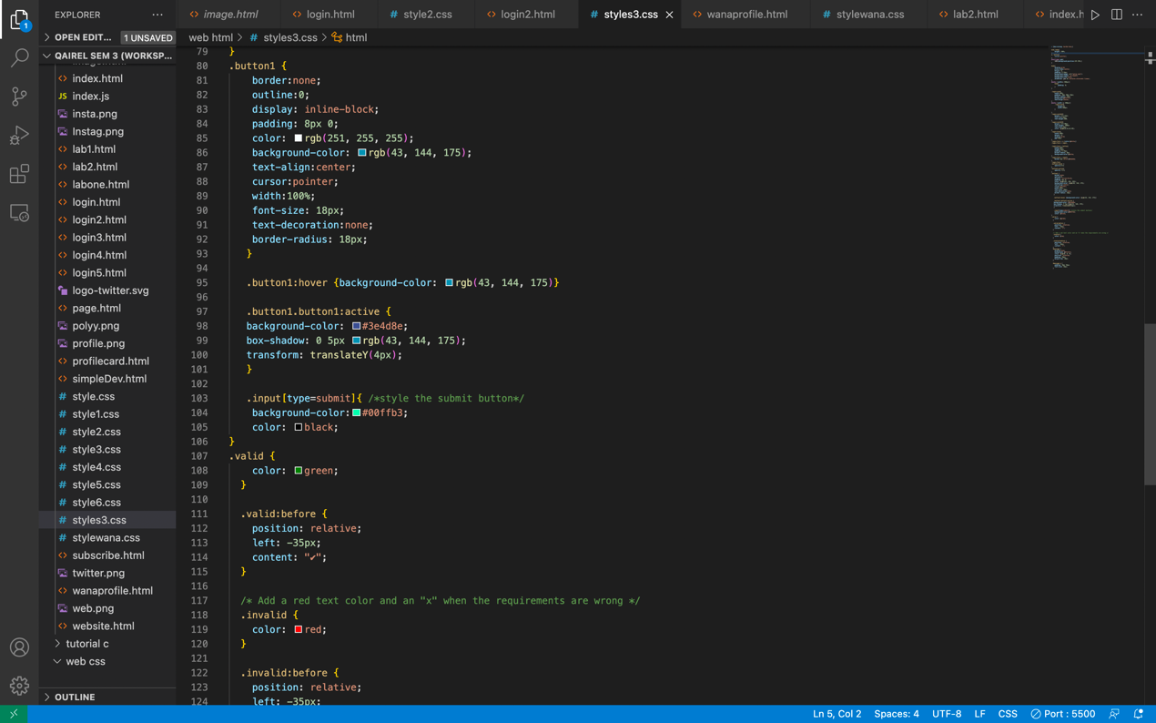

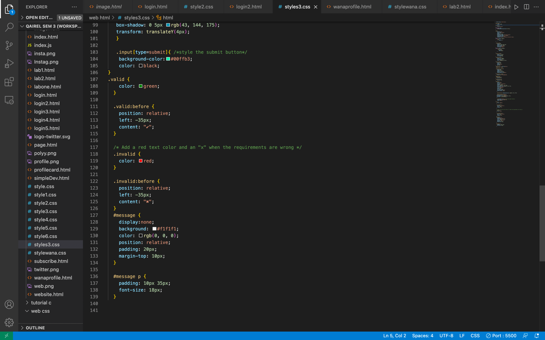

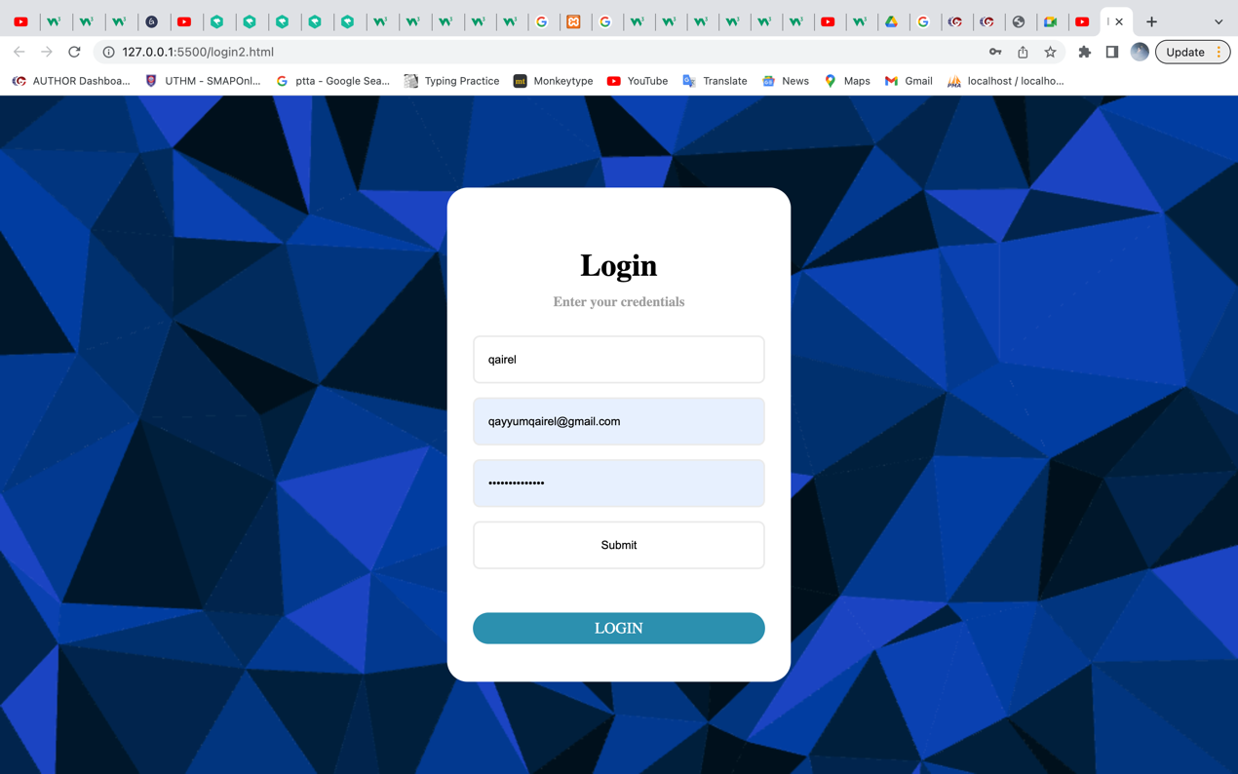

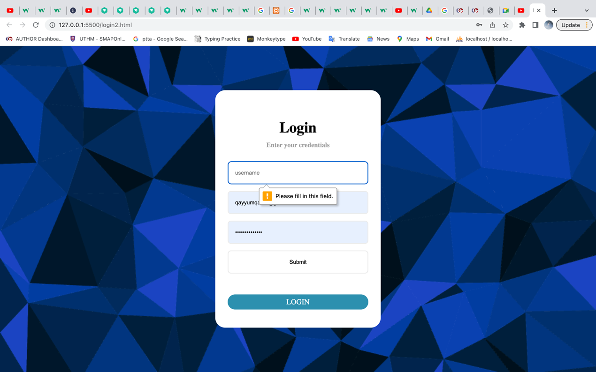

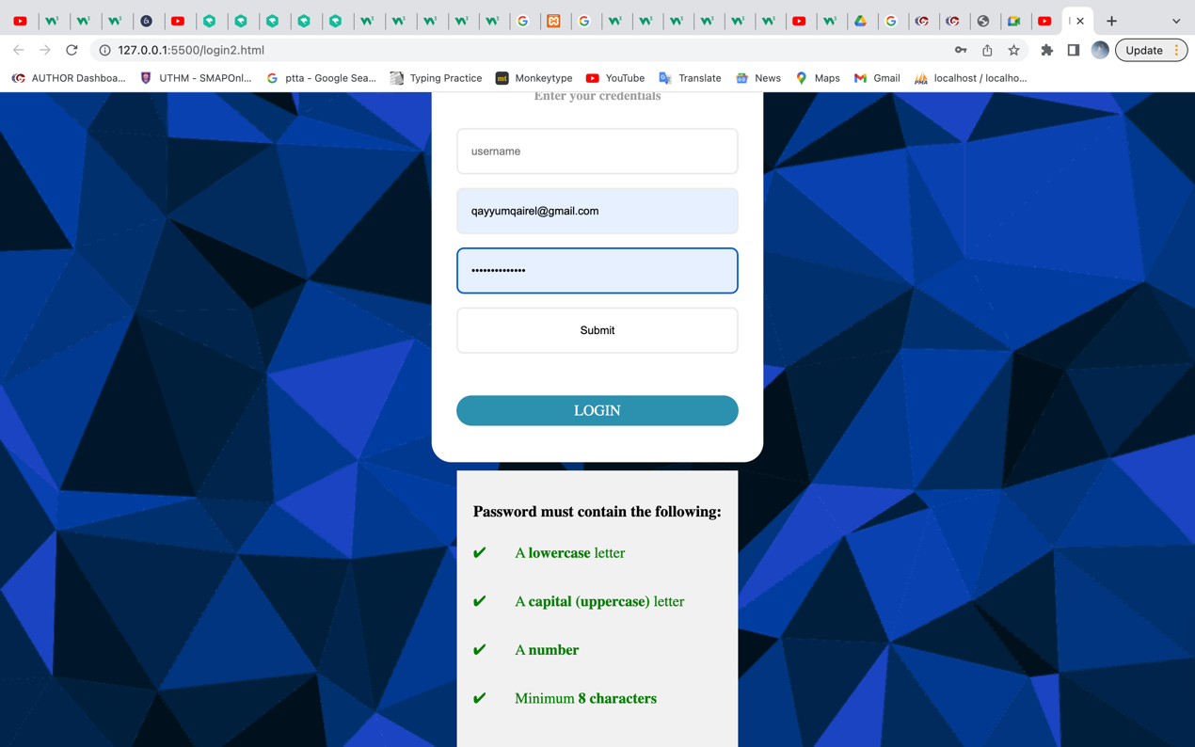

***Question 4: Write down a conclusion of your works about HTML, CSS and JavaScript. Your words must not exceed 400 words.***

HTML is on the center of each net web page, regardless the complexity of a domain or quantity of technology involved. It's a vital talent for any net professional. It's the start line for everybody gaining knowledge of a way to create content material for the net. It is straightforward to learn. HTML stands for Hyper Text Markup Language. "Markup language" method that, in preference to the use of a programming language to carry out functions, HTML makes use of tags to pick out special styles of content material and the functions they every serve to the webpage. Markup languages paintings withinside the identical manner as we did whilst we categorized the ones content material types, besides they use code to do it specifically, they use HTML tags, additionally regarded as "factors." These tags have quite intuitive names: Header tags, paragraph tags, picture tags, and so on. Every net web page is made from a gaggle of those HTML tags denoting every kind of content material at the web page. Each kind of content material at the web page is "wrapped" in, i.e., surrounded through, HTML tags.

CSS stands for Cascading Style Sheets. This programming language dictates how the HTML factors of an internet site need to seem at the frontend of the web page. If HTML is the drywall, CSS is the paint. Whereas HTML turned into the primary shape of an internet site, CSS is what offers the complete internet site its style. Those slick colors, thrilling fonts, and history pics are all way to CSS. This language influences the complete temper and tone of an internet web page, making it a very effective device and a critical talent for net builders to learn. It's additionally what lets in web sites to conform to special display screen sizes and tool types.

JavaScript is an extra complex language than HTML or CSS. Nowadays, JavaScript is supported through all cutting-edge net browsers and is used on nearly each web website online at the net for extra effective and complicated functionality. In short, JavaScript is a programming language that shall we net builders layout interactive sites. Most of the dynamic conduct you may see on an internet web page is way to JavaScript, which augments a browser's default controls and behaviors. The examples are growing affirmation boxes, triggering slide, storing new data, manipulate shape and lots extra beneficial functions.